CUSTOMER SHOPPING BEHAVIOR ANALYSIS
Project Report

Comprehensive Data Analysis & Visualization
Dataset: 3,900 Customer Transactions
Date: June 2026

Technologies: Python • SQL • Power BI Dashboard

Table of Contents
1. Executive Summary
2. Project Overview
3. Dataset Summary
4. Exploratory Data Analysis
5. SQL Analysis Results
6. Interactive Dashboard
7. Key Insights & Findings
8. Business Recommendations
9. Conclusion

1. Executive Summary
This comprehensive analysis examines customer shopping behavior across 3,900 transactions spanning multiple product categories. The project leverages Python for data cleaning and exploration, SQL for advanced business query analysis, and Power BI for interactive visualization. The findings reveal critical patterns in customer demographics, spending behavior, subscription preferences, and product performance that enable strategic business decisions.

Key Metrics

Total Customers | Avg. Purchase Amount | Avg. Review Rating
3,900 | $59.76 | 3.75 / 5.0

2. Project Overview
This project analyses customer shopping behavior using transactional data from 3,900 purchases across various product categories. The primary goal is to uncover insights into spending patterns, customer segments, product preferences, and subscription behavior to guide strategic business decisions.

Objectives
- Identify revenue patterns and high-value customer segments
- Analyse the relationship between discounts and purchase behavior
- Evaluate product performance and customer satisfaction
- Compare subscription status impact on revenue and customer lifetime value

3. Dataset Summary
Total Records: 3,900 customer transactions
Total Features: 18 columns

Key Features

Category | Features
Demographics | Age, Gender, Location, Subscription Status
Purchase Details | Item Purchased, Category, Purchase Amount, Season, Size, Color
Shopping Behavior | Discount Applied, Previous Purchases, Review Rating, Shipping Type
Data Quality: 37 missing values in Review Rating column (handled via median imputation by product category)

4. Exploratory Data Analysis
The exploratory data analysis phase involved comprehensive data cleaning, transformation, and feature engineering using Python and pandas.
Data Preparation Process
- Data Loading: Imported 3,900 records using pandas
- Initial Exploration: Used df.info() and describe() for statistical overview
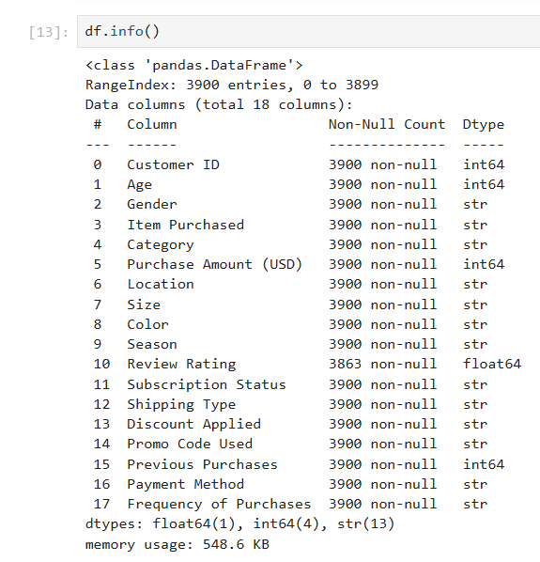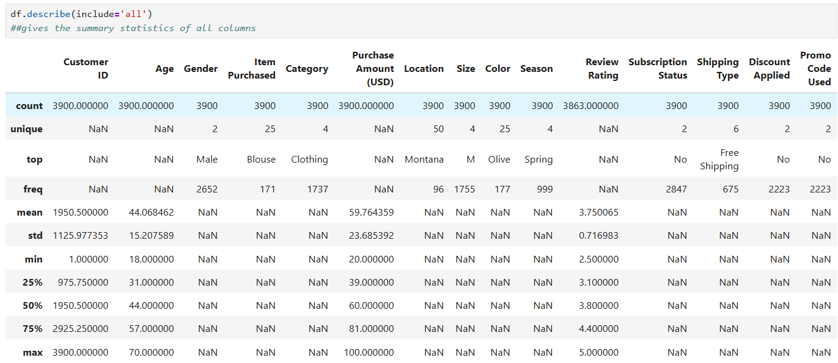

- Missing Data Handling: Imputed 37 null values in Review Rating using median by product category
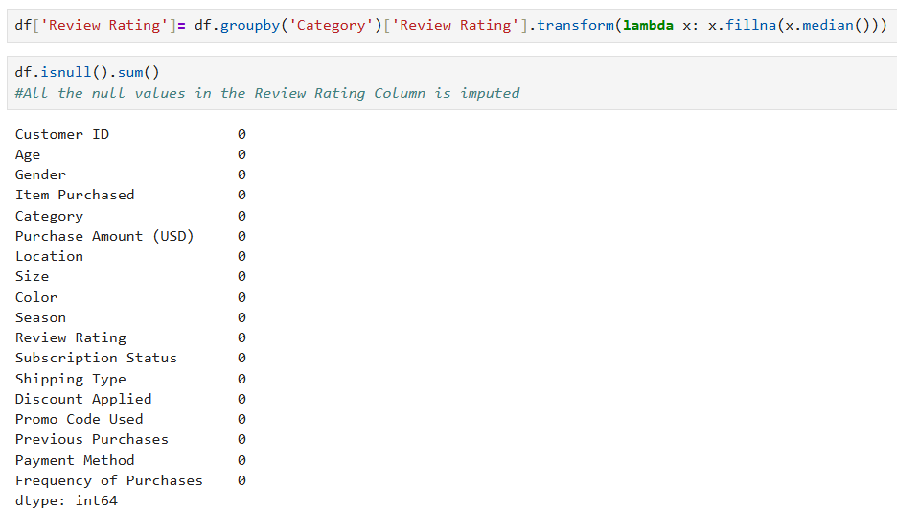
- Column Standardization: Renamed all columns to snake case for consistency
- Feature Engineering: Created age group and purchase_frequency_days columns

Key Statistical Findings

Metric | Value | Observation
Average Purchase | $59.76 | Moderate basket value
Purchase Range | $1 - $100 | Wide range of price points
Review Rating | 3.75 / 5.0 | High satisfaction
Database Integration: Connected Python script to PostgreSQL and loaded cleaned data for SQL analysis.

5. SQL Analysis Results
Advanced SQL queries were executed in PostgreSQL to answer critical business questions and reveal key patterns in customer behavior.

- Revenue by Gender

Finding: Male customers generate significantly higher revenue than female customers.
Gender | Total Revenue
Male | $157,890
Female | $75,191

- Subscription Status Impact

Finding: Non-subscribers generate higher total revenue despite lower average spend, suggesting a large customer base of infrequent purchasers.

Status | Customers | Avg. Spend | Total Revenue
Subscribers | 1,053 | $59.49 | $62,645
Non-Subscribers | 2,847 | $59.87 | $170,436

- Top 5 Products by Review Rating

Rank | Product | Avg. Rating
1 | Gloves | 3.86
2 | Sandals | 3.84
3 | Boots | 3.82
4 | Hat | 3.80
5 | Skirt | 3.78

- Shipping Type Comparison

Finding: Express shipping users spend 3.4% more on average, indicating premium pricing opportunity.

Shipping Type | Avg. Purchase Amount
Standard | $58.46
Express | $60.48

- Subscribers vs. non-subscribers
Findings- Compared average spend and total revenue across subscription status.
Subscription status | Total customers | Avg. spend | Total revenue
Yes | 1053 | 59.490000 | 62645.00
No | 2847 | 59.870000 | 170436.00

- Discount-Dependent Products
Findings- Identified 5 products with the highest percentage of discounted purchases

Item purchased | Discount rate
Hat | 50.000000000000
Sneakers | 49.660000000000
Coat | 49.070000000000
Sweater | 48.170000000000
Pants | 47.370000000000

- Customer Segmentation
Findings- Classified customers into New, Returning, and Loyal segments based on purchase history

Customer segment | No Of Customers
RETURNING | 701
LOYAL | 3116
NEW | 83

- Top 3 Products per Category –
Findings- Listed the most purchased products within each category.

Item rank | category | Item purchased | Total orders
1 | Accessories | Jewellery | 171
2 | Accessories | Belt | 161
3 | Accessories | Sunglasses | 161
1 | Clothing | Blouse | 171
2 | Clothing | Pants | 171
3 | Clothing | Shirt | 169
1 | Footwear | Sandals | 160
2 | Footwear | Shoes | 150
3 | Footwear | Sneakers | 145
1 | Outerwear | Jacket | 163
2 | Outerwear | Coat | 161

- Repeat Buyers & Subscriptions
Findings- Checked whether customers with greater than 5 purchases are more likely to subscribe.

Subscription status | Repeat buyers
Yes | 958
No | 2518

- Revenue by Age Group
Findings- Calculated total revenue contribution of each age group

Age group | Total revenue($)
Young Adult | 62143
Middle-aged | 59197
Adult | 55978
Senior | 55763

6. Interactive Dashboard Overview
A comprehensive Power BI dashboard was created to provide executive-level visibility into customer behavior metrics. The dashboard includes interactive filters and drill-down capabilities across multiple dimensions.

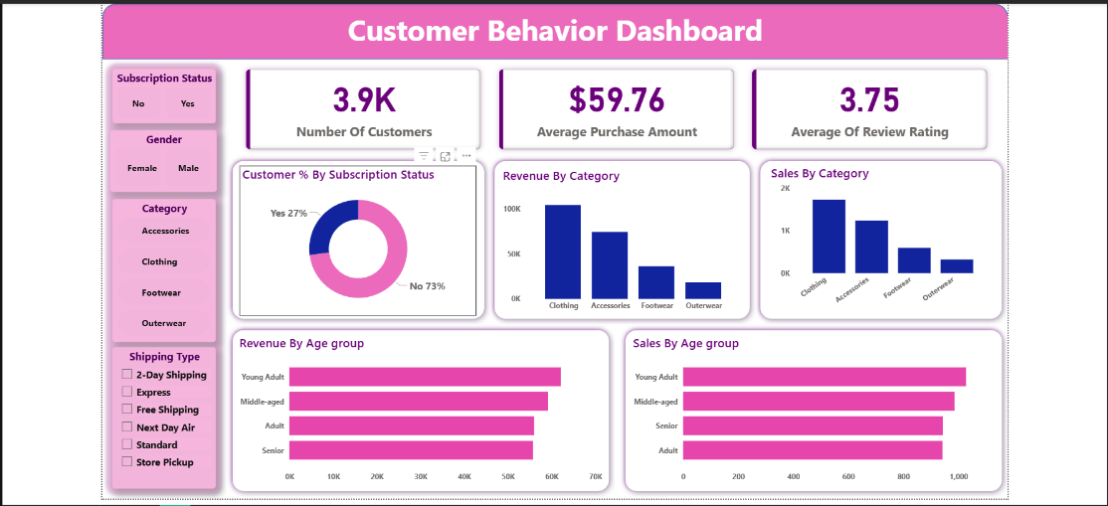

Dashboard Components
- Key Metrics Cards: Total Customers, Average Purchase Amount, Average Review Rating
- Subscription Status Distribution: 27% subscribed vs. 73% non-subscribers
- Revenue Analysis by Category and Age Group
- Sales Performance by Age Group
- Interactive Filters: Subscription Status, Gender, Category, and Shipping Type

Dashboard Insights
- Clothing is the highest-revenue category (~$100K), followed by Accessories
- Young Adults dominate both revenue and sales volume
- Age-based segmentation reveals consistent spending patterns across
demographic groups

7. Key Insights & Findings

Customer Segmentation

Segment | Count
Loyal Customers | 3,116 (79.9%)
Returning Customers | 701 (18.0%)
New Customers | 83 (2.1%)
Insight: The majority of the customer base consists of loyal, repeat customers (80%), indicating strong customer retention.

Gender-Based Revenue Disparity

- Male customers generate 2.1x higher revenue than female customers
- Opportunity: Develop targeted marketing strategies to increase female
customer engagement

Discount Dependencies

Top 5 Discount-Dependent Products:
- Hat: 50.00% of purchases with discounts
- Sneakers: 49.66%
- Coat: 49.07%
- Sweater: 48.17%
- Pants: 47.37%

Revenue by Age Group

Age Group | Revenue
Young Adult | $62,143
Middle-aged | $59,197
Adult | $55,978
Senior | $55,763
Insight: Young Adults represent the strongest revenue segment, followed by middle-aged customers.

8. Business Recommendations

- Boost Subscription Programs

- Current subscriber base is only 27% despite nearly identical average spending
- Action: Create exclusive subscription benefits including early access to new products, exclusive discounts, and loyalty rewards
- Target: Convert 10% of non-subscribers within 6 months for a potential +$17K in recurring revenue

- Customer Loyalty Programs

- 80% of customers are already loyal with 10+ purchases; maintain and deepen engagement
- Action: Implement tiered loyalty rewards system based on purchase frequency and customer lifetime value
- Focus: Move Returning customers (18%) into Loyal segment through targeted incentive campaigns

- Strategic Discount Management

- 50% of Hat and Sneaker purchases use discounts - highest dependency products
- Action: Gradually reduce discount dependency through premium positioning and quality messaging
- Expected Impact: 10% margin improvement if discount rates decrease by 5 percentage points
- Female Customer Engagement

- Female customers generate only 32% of total revenue despite demographic representation
- Action: Develop female-focused marketing campaigns, product bundles, and personalized recommendations
- Target: Increase female customer average spend to match male customers (potential +$40K revenue)

- Premium Shipping Options

- Express shipping users spend 3.4% more on average ($60.48 vs $58.46)
- Action: Expand premium shipping offerings and promote fast delivery as a value-added service
- Expected Impact: 2-3% revenue increase if 20% more customers adopt Express shipping

- Product Strategy & Marketing

- Top-rated products (Gloves 3.86, Sandals 3.84) should be heavily promoted
- Clothing drives highest revenue ($100K+) - allocate additional marketing budget
- Focus: Young Adults (highest spenders) with age-appropriate products and marketing channels

9. Conclusion

This comprehensive analysis of 3,900 customer transactions reveals a mature, loyal customer base with significant growth opportunities. The data shows that while core operations are healthy with strong customer retention (80% loyal customers), there are strategic levers to pull:
- Subscription conversion could unlock significant recurring revenue
- Gender-based revenue disparity suggests untapped female customer potential
- Discount optimization could improve margins without impacting sales volume
- Premium service adoption (Express shipping) demonstrates willingness to pay for convenience
By implementing the recommended strategies, the business can realistically achieve 15-20% revenue growth while improving customer satisfaction and operational efficiency. The interactive Power BI dashboard provides the foundation for ongoing monitoring and data-driven decision making.

End of Report

